**EC2**

We need an account to work on any AWS component. EC2 instance is nothing but AMI (Amazon Machine Image).

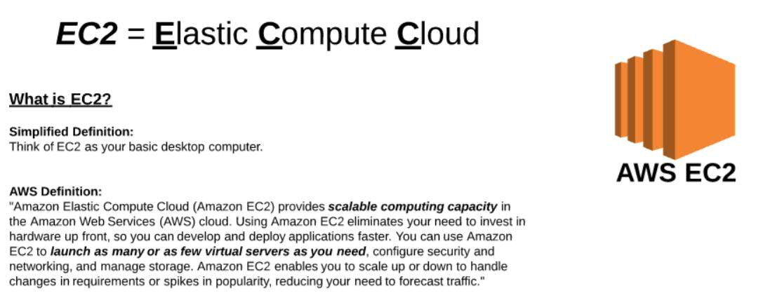

Differences between AWC EC2 and basic computer? What are the components we have in our computer and what are equivalent for those in AWS.

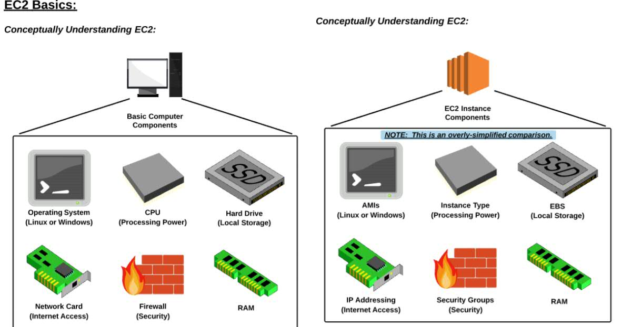

**Creating instance using AMI:**Login to AWS console. Go to **Services** ->**EC2** -> **Launch Instance**.  
Then enable the **Free tier only** checkbox, then we can see only free tire images. Then choose an AMI and click on Select.

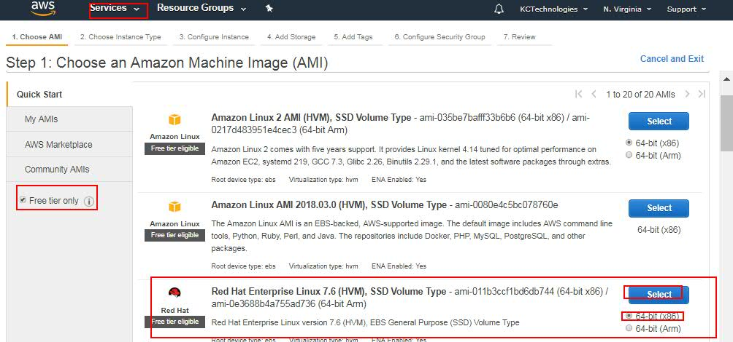

Then select the Instance Type (Here we select t2.micron for free tire) and click on **Next: Configure Instance Details**.

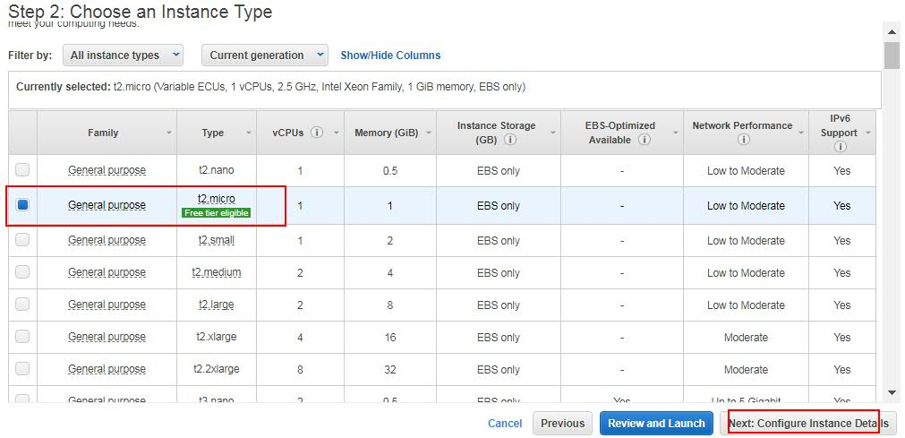

Then select the Network Settings. For now, go with default details and click on Next.

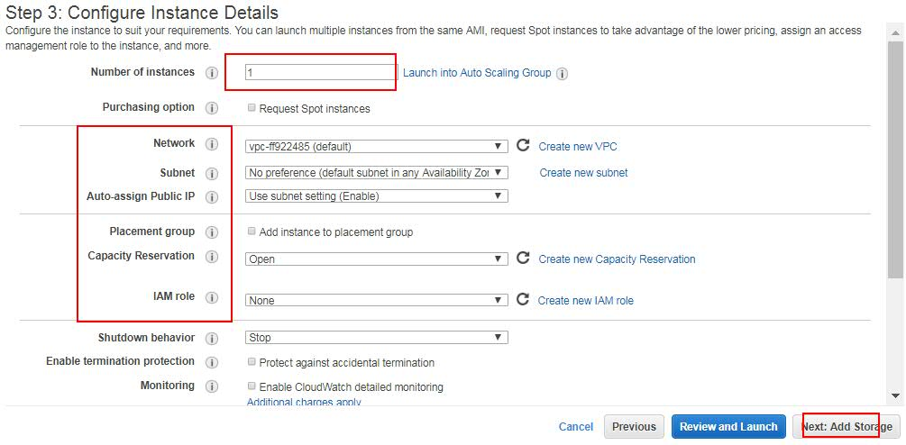

Then select the Hard disk memory. As for now go with default 10 GB and click on Add Tags.

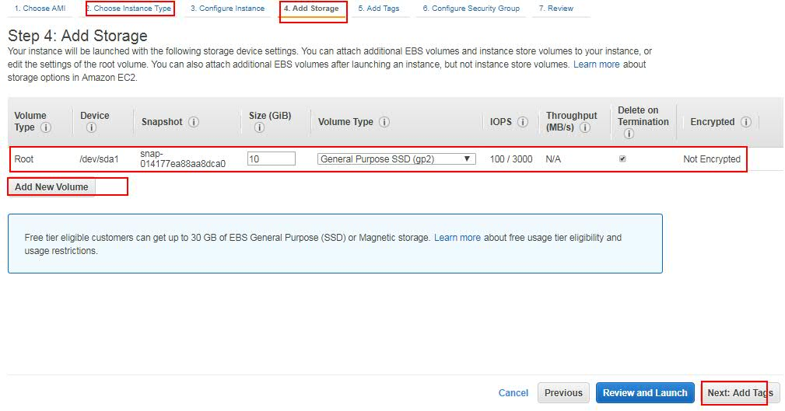

Then give the tag name and then click on **Next: Configure Security Group**. Tag is nothing but a name for identification purpose.

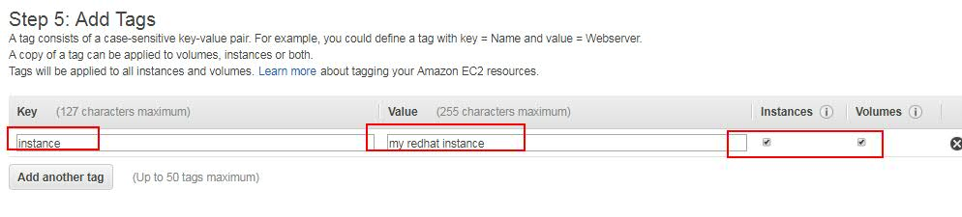

Security Group is nothing but a firewall. Here we will open the port numbers what we want. Open the Secure Shell port (22) so that we can connect to this machine from our local machine through SSH. Then click on **Review and Launch.** 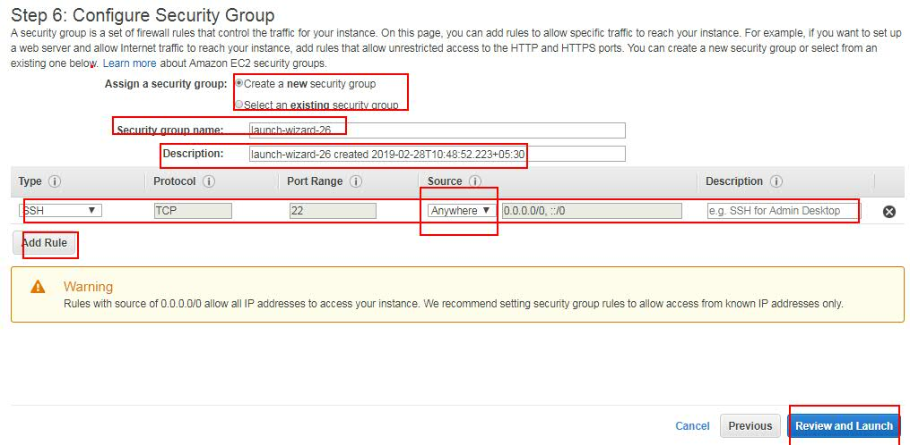

Then, review the changes and click on Launch. So that a popup will be opened to select/create a new key pair. Based on the key pair, a pem file will be created.  
We use this pem file to authenticate AWS machine while connecting from local to AWS machine. Like username and password we use pem file (private key pair)to do authentication to AWS.

We can choose an existing file or we can create a new key pair. If not, then key a keypairname, so that a new pem file will be created for you. Then download the pem file and secure it on local as it is available only once.

Then click on **Launch Instance**.

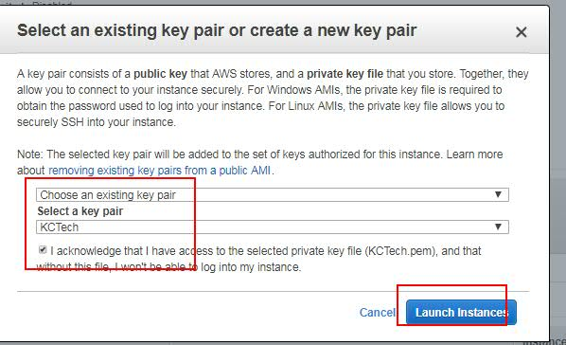

Now, to connect to this machine from local, got to the local where the pem file is saved and then open git bash from windows machine or terminal from mac machines.   
Then go to AWS console and click on Connect option.

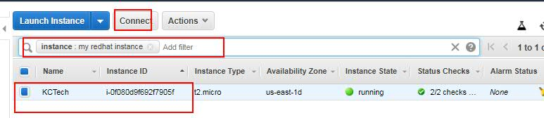

Then an SSH command will be shown. Copy it and execute from git bash. Then you will be connected to the instance created on AWS.  
After successful connection, switch as root use using: **sudo -i**

Then we can do any operations as we do on Linux.  
**Ex:** **yum install httpd -y** 🡪 To install http server.

**service httpd start** 🡪 To start http server.

**service httpd status** 🡪 To check the status.

Now try to access the http server from browser. As http server runs on 8080 port number, we need to allow that port number from AWS **Security Groups**.

For that, go to AWS console, select the AMI we created and click on **Security Groups**. There you can see one option called **Inbound** rules. Click on it, then click on **Edit**, then **Add rule** for http for the port number and from where that has to be enabled.

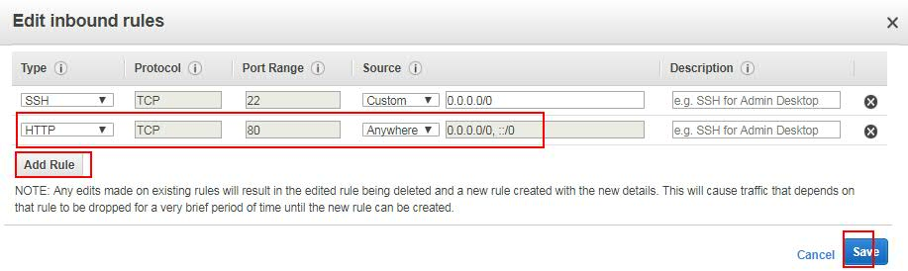  
Then click on save. Then try to access the http server from browser using:  
<http://publicipaddress:80> . So you can see the console of http server.  
  
When creating an EC2 instance, we have different Purchase options.

1. On-Demand
2. Reserve
3. Spot

**On-Demand**

Whatever we have done so far is On-Demand. It is charged based on hours. On Demand can be used and terminated at any time, we don’t give any commitment saying we use it for particular duration. On-Demand is the costlier way to create EC2 instance.

**Reserved:**

In server, we give a commitment that we are going to use this instance for particular duration of time like 1 year or n years. So the charge will be drastically reduced. Whether we use it or not, it will be charged.

**Spot:**In amazon, there will lot of unused instance. To generate revenue out of it, AWS gives an option of bidding. Spot we don’t use for production purpose.

<https://docs.aws.amazon.com/AWSEC2/latest/UserGuide/instance-purchasing-options.html>

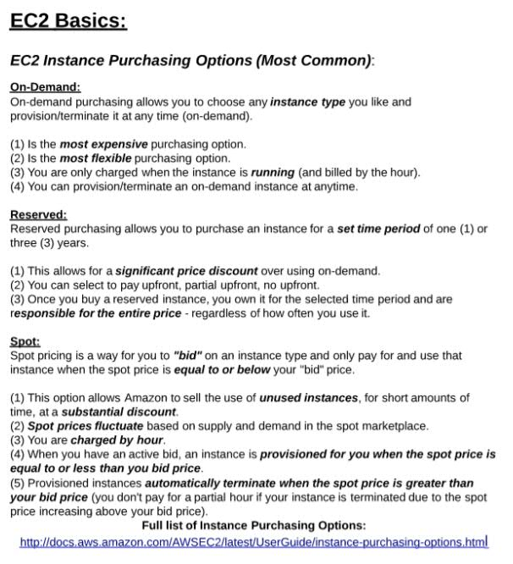

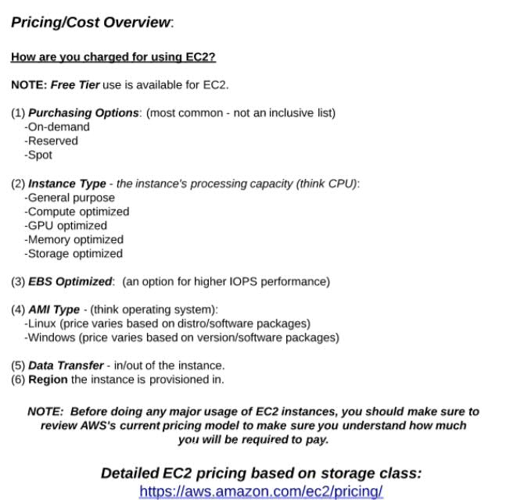

Now compare the pricing for On-Demand and Reserved by changing the region.

To save our billing of free account, we can stop the instance, once we are done with our work, and again start it when you want to work on it. So, the free time duration will not be calculated. But the hard disc storage will be calculated.   
  
  
Every EC2 instance will have public and private ip addresses. When you stop and start an instance, then the public Ip address of the instance will be changed, but not the private ipaddress. We have some ways to retain the public ip address like Elastic Ip.

The way how we created a Linux instance, in the same way we can create Windows machine and download the pem file. Difference is windows uses RDP (Remote Desktop Protocol) and Linux users SSH to communicate. Linux uses 22 and Windows uses 3389 as the port numbers.

But when we connect from local to Windows instance its bit different as we don’t have SSH in windows.

For this click on the **connect** option on AWS UI console. Then click on **Get Password** option. Then select the **Choose file** option and select the pem file location. Then click on **Decrypt password** option. So an username (Administrator) and password will be generated, copy the password. Then download the **Remote Desktop file**. Then open the downloaded Remote Desktop file, then click on **connect**, then give the password we copied and click on ok. So, an windows system will be shown.

**AMI (Amazon machine Images):**Using AMI’s, we can choose Operating Systems or predefined software installed versions, or we create our own AMI’s. For every image we create in Amazon, an id will be created and using it amazon recognizes each image.

Once we login to AWS console and select EC2 services, then we can see My AMI, AWS Marketplace and Community AMIs.  
Community AMIs contains the images what we used so far like RedHat.  
  
AWS Marketplace contains the images of 3rd parties. Most of them are paid software’s, but also we can find few free trial version. Here costing for this software’s includes the Cost of the Software + EC2 pricing.  
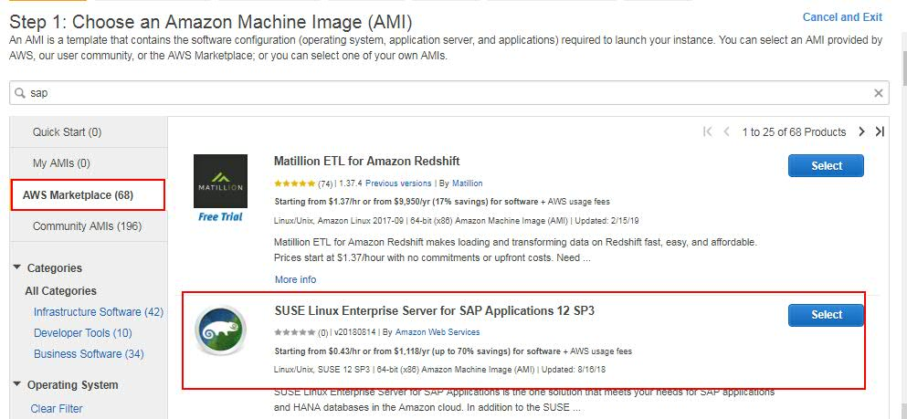

In the Search box, if you type Sap and search, then you can see SAP related Software’s which are from 3rd party.  
If you search for SharePoint, then you can see SharePoint related software’s including free trials.  
  
While creating custom images, we can take an Linux OS and install what we want on it and then generate an image. Or else we can use tools like **Packer** Configure the OS system and do what we want on it, so it will generate a custom image for us.

While creating an instance, if we select Amazon Linux AMI which is similar like RedHat, but has some pre-installed software’s like Python, AWI console.

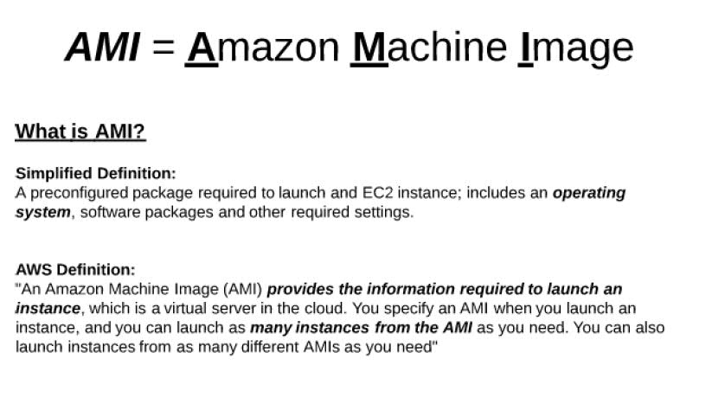

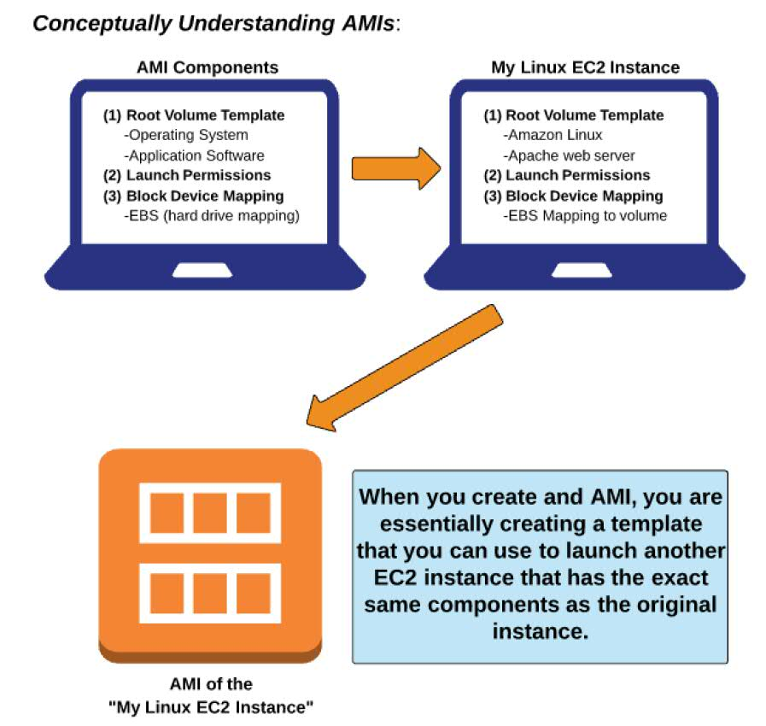

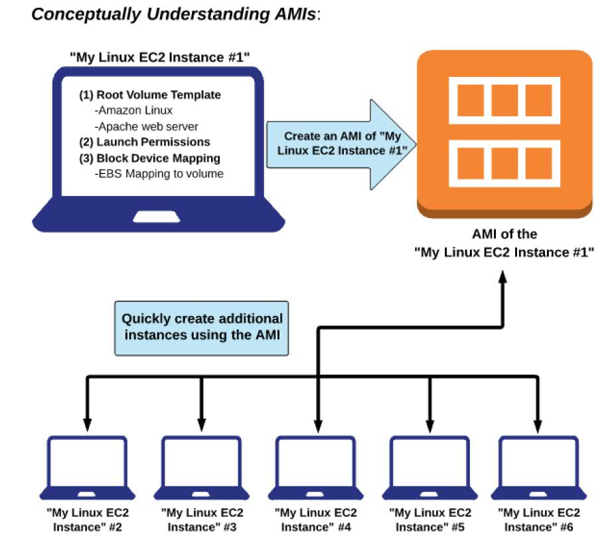

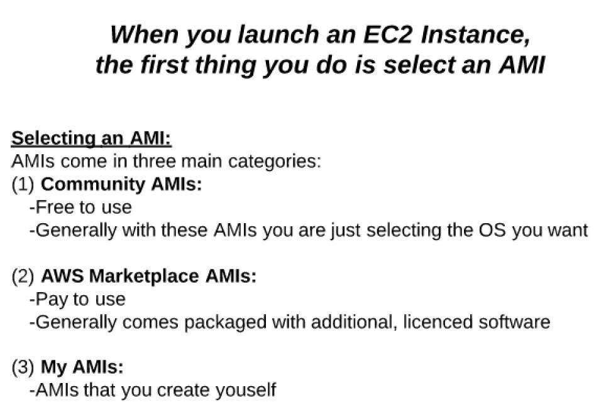

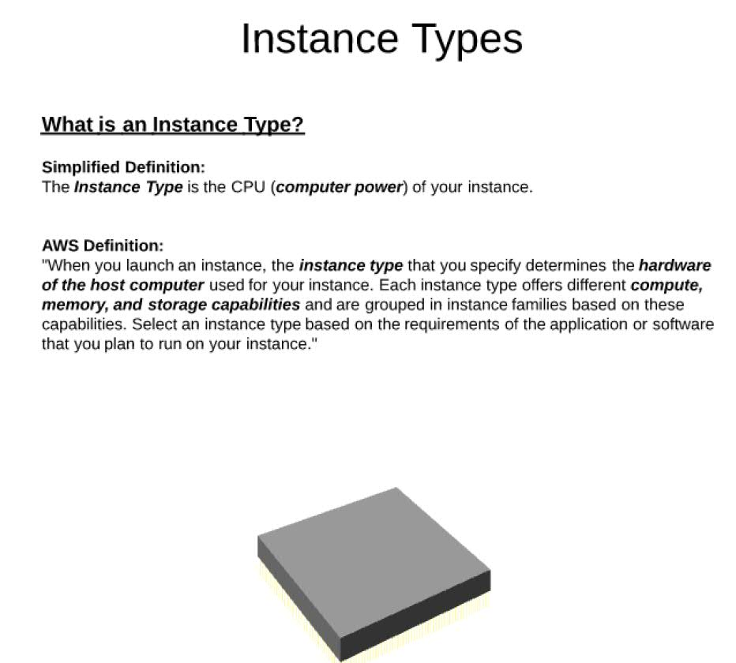

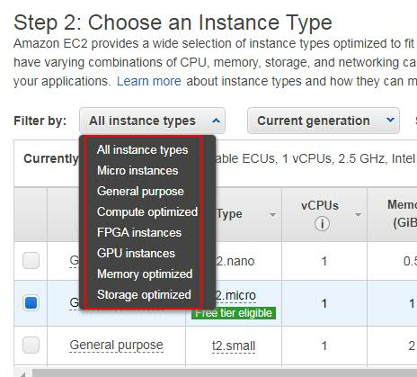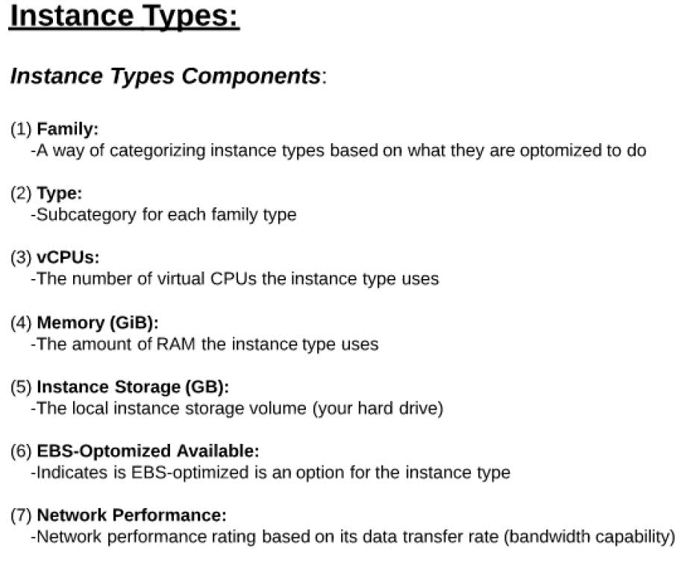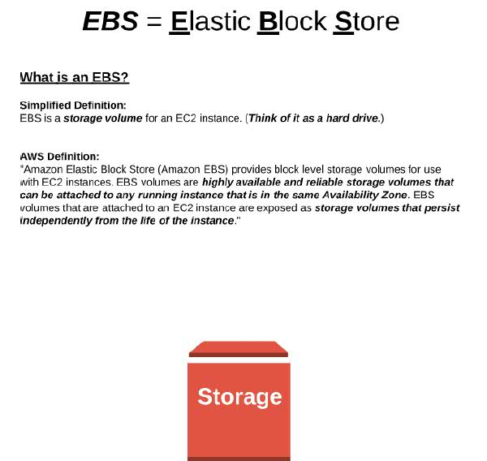

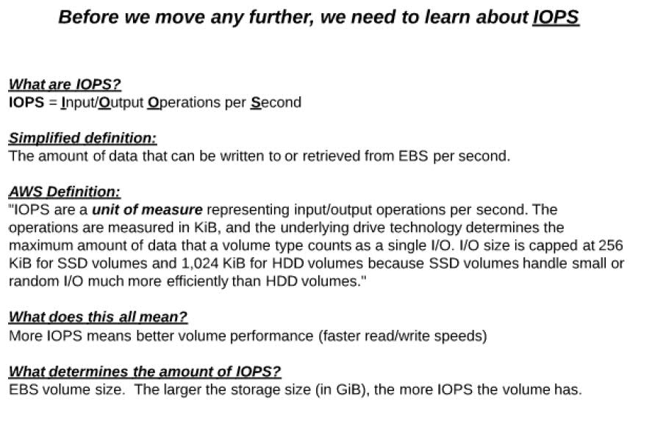

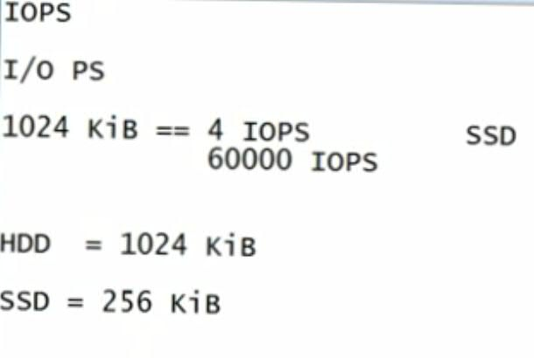

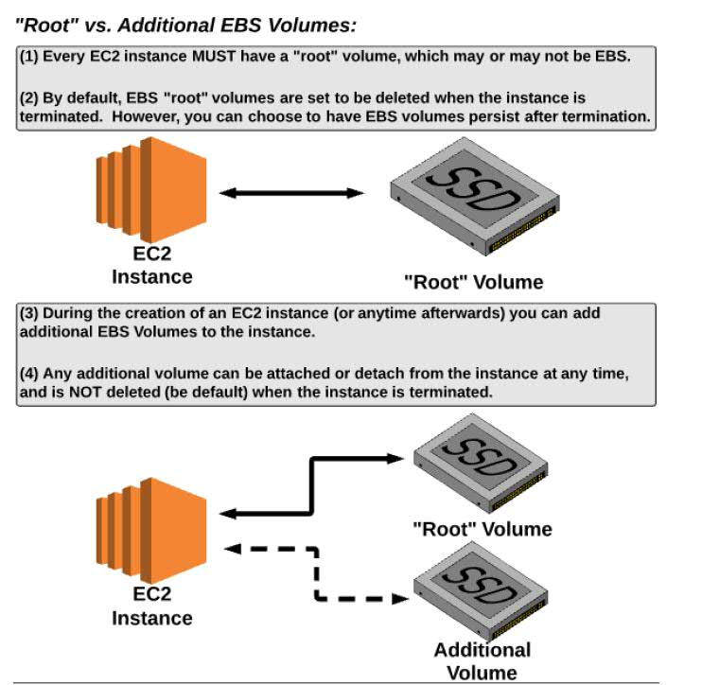

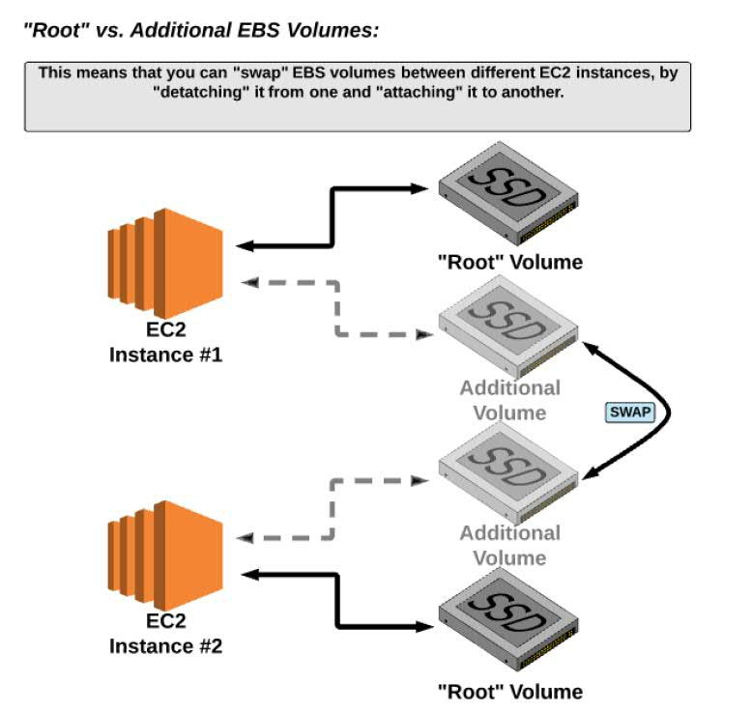

Root volume is of 2 types: 1) Ephemeral 2) Non-Ephemeral

**Ephemeral** is which deletes the H/D when we terminate an instance and whatever on Root volume gets deleted.  
**Non- Ephemeral**: EC2 instance may die, but still our volume (H/D) exists.

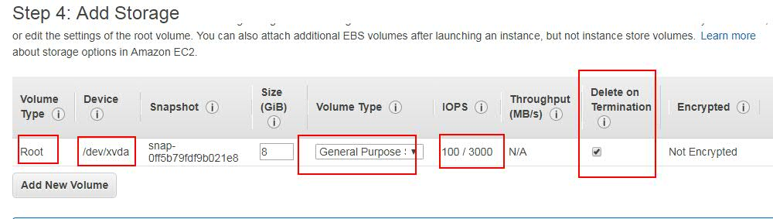

While creating an instance, if we enable “**Delete on termination**” checkbox, then the volume will be deleted on termination. If it is un selected, then volume will still exist even after Instance termination.

You can add volume by clicking on “**Add new Volume**”. We can add as many as volumes as per our requirement. And this is chargeable.

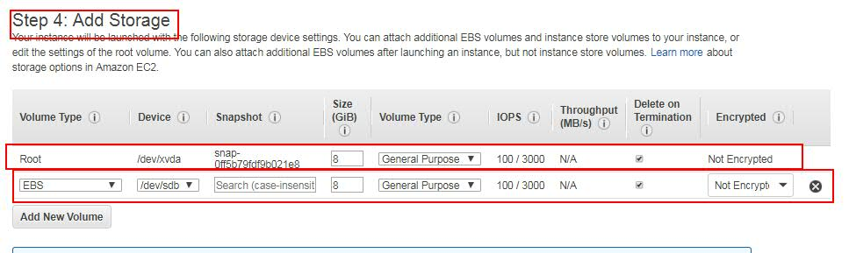

To understand about EBS, go to EBS amazon documentation by searching in google for “ebs storage amazon” and go to storage. Or click on below link.

<https://docs.aws.amazon.com/AWSEC2/latest/UserGuide/Storage.html>

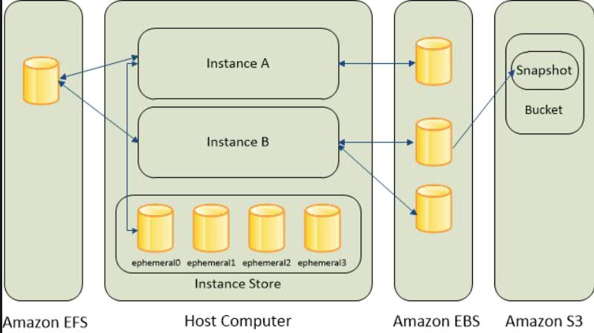

Instance Storage comes along with instance and will be deleted when we delete instance.   
EBS comes out side of instance but within AWS network. It will not be deleted when we delete instance unless we want to delete in termination.  
  
We can have multiple EBSs used by single instances.   
If we want to use same external memory by multiple instances (shared), then we go for **EFS**.

And S3 is not like a hard disk. It is an object storage like box or google drive which is external to system drive.

**Burstable:**

Generally, if we have an 8GB of RAM to our machine, then it cannot be increased or decreased its size at some particular point of time in a day. But AWS will provide this flexibly using a concept called **Burstability**.

Just think, once in a day for a shorter period of time, there are many jobs running on your system like Cron jobs or batch jobs band you need many IOPS, CPUs and more RAM size and in the idle times you have not used your actual system capability. Then Burstable is the concept in Amazon which provides this facility to increase the System size (CPU, RAM, IOPS) which is beyond our limits for a shorter period of time. Wherever we see an instance starting with **t2**, it means it is burstable.   
Burstable can be applied to instances and storages too. In case of Storage, IOPS will increase. In case of instance, CPU or memory will be increased.

In real-time, this burstable concept comes into picture when we run Cron Jobs or batch jobs. **Ex:** All bank transfer transactions are done in a day at particular intervals.  
  
**RAID on EBS**: search for it in google.

**Restrictions on EBS:**

While creating EBS, instance and EBS should remain on same availability zone.

EBS is Non-ephemeral storage (H/D will be killed when we terminate instance).  
EBS volume can be attached to only instance present in the same availability zone.  
EBS can be attached to only 1 instance. It cannot be attached to multiple instances. (To achieve this, we use EFS).

The storage (Root volume) that comes with instance is called **instance storage**. EBS is like external hard disk, which is present on other system and in same network, which has to be mounted to the instance.  
Every AWS EBS we create is like a Linux mount.

EBS speed is measured in IOPS i.e, how much data we can read and write with in a second. For SSD disk, 256Kib is the unit, so for example, if we are able to read or write 512Kb, then 512/256 = 2, i.e our disk is giving 2 IOPS.

When using HDD disk, then it is of 1024 Kib. If we are able to read or write 1024Kb, then 1024/1024 = 1, i.e our disk is giving 1 IOPS.

**Creating EBS and types of EBS:**

First create and EC2 Linux instance (Ex: Amazon Linux AMI, which is enhanced of RedHat).

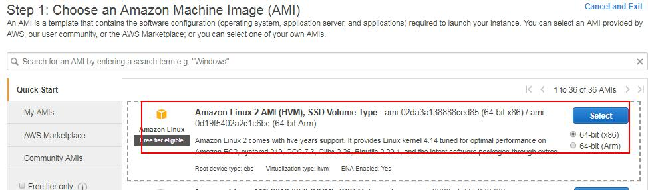

Then select, **t2.micron** Type and click on Configure Instance details.

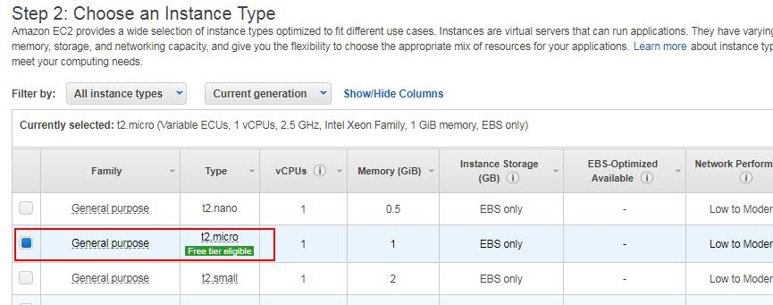

Then select the subnet. Ex: **Default in us-west-2c**  and click on **Add Storage**.

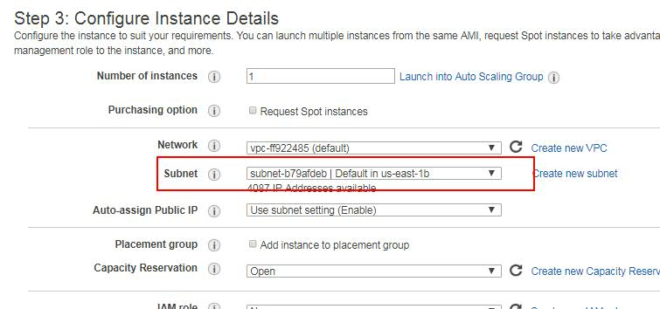

Then, select the Volume Type as “**General Purpose SSD (GP2)”** for now.

There we can see the IOPS as 100/3000. Which means 100 IOPS are allowed and can be burstable (expanded) up to 3000 in peak times (if we have preserved).

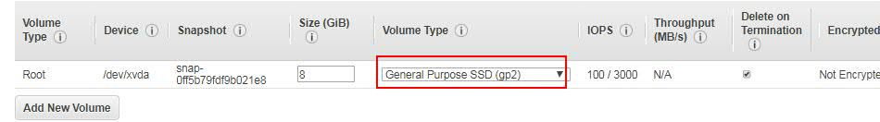

Then add the **tag**, then add the default **Security groups** with SSH access, then click on **Review** **and** **Launch**. Then click on **Launch**.  
Then select the key pair and connect from local to AWS instance using pem file. Then switch as root user.

Now, in the AWS console, go to “**Description**” and check the details of the created instance.

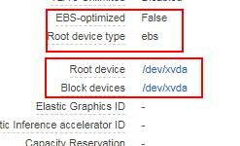

Block devices indicates, no.of devices connected. Here, we have only 1 as we have only 1 internal device and no external devices connected.

From terminal type: **df -h** to know cross check the details.

In recent times of AWS, we no need to restart the instance after attaching Volume. So, we can attach a Volume to a running instance without using restart.

**Types of EBS in AWS:**

1. General purpose SSD (GP2).
2. Provisioned IOPS SSD (Faster).
3. Magnetic (slower).

**Creating Volume and attaching:**

After attaching volume, using it is taken care by Linux and we don’t do anything about its usage.  
**First let’s try to create and attach it.**

Login to AWS console, then go to EC2 console, then click on the **Volumes** option under **Elastic Block Storage** option on left side.

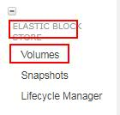

So, all the existing Volumes will be listed.

Then to create a Volume, click on Create Volume option.

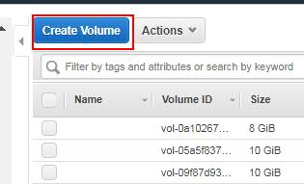

Then, select the type of Volume. **Ex: General Purpose SSD (GP2).**

Size as GiB. For free tier accounts don’t go beyond 10GiB to avoid unnecessary billing.

Then select the same Availability Zone what we have for our instance.

Then click on **Create** button.

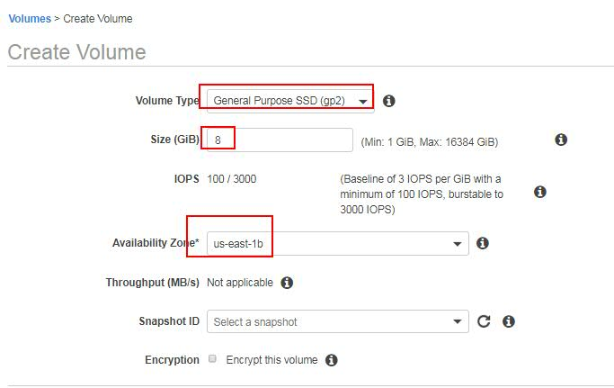

Then, if we refresh the console, we can see the state of the Volume as “**available**”. If means, the volume is not yet used by any instance and it is ready to use. Status, “**in-use**” indicates that the Volume is attached to an eeeeeeeeeeeeeeeeeeeeeeeeeeeeeeeeeeeee3

6instance and we cannot use any more until it is detached.  
Give some name to the Volume for recognition purpose. EX: **MYEBS.**

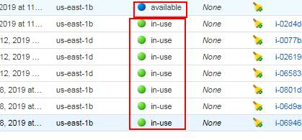

**Now we have a Volume and we need to attach it to the instance.**

For this, select the Volume, then go to the **Actions** dropdown and select the **Attach volume**. Then we will see a overlay, there we have to search and select the instance to which we want to attach this volume.

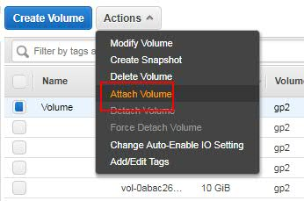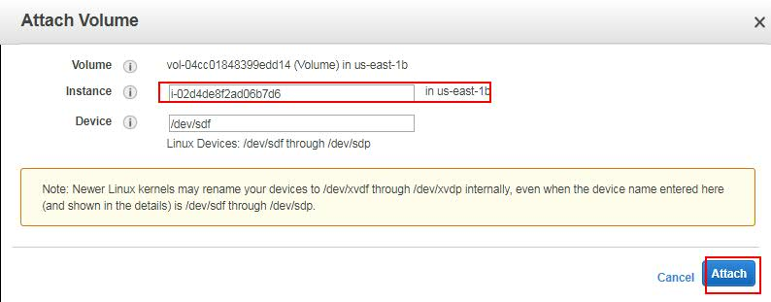

Then click on **Attach**. So, after a while, volume will be attached to the instance and we can see the status of the Volume as “**in-use**”.

So far, we added a volume to the instance. Now we have to allocate a File System to it and then we have to do mount.

As we have got an unformatted system, first we have to format and then we have to give File System and do mounting. All the commands we use here are pure LINUX commands and nothing related to AWS. Its pure Linux mounting.

**Access volume to an instance**

Its better if we use root user to do this or use sudo access.

After attaching volume try **sudo df -h** and we can see nothing has changed in the mounts.

Using **sudo fdisk -l**, check whether any external disk is added to the instance. So, you can see the EBS volume has be added, but it is unformatted.

So format it using **sudo mkfs -t ext4 /dev/xvdf.** With this formatting has done and we have to mount it.

(For formatting in Windows, we use **fat** or **nfts**).

For this create a dummy directory and try to create mount of that using **sudo mkdir /mydir**

To mount it use: **mount /dev/xvdf /mydir/**

Now, if we use: **df -h** then we can see the newly created mount.

Now, select the instance and check the Description, there you can see the **Block devices** has been changed.

**Note:** Then mount we created now is a temporary mount. Mount will be removed when we restart the instance. For permanent mounting we have to use **etc/fstab**.

**Note:** When the mount is in use, we cannot delete the Volume anymore. We have to unmount it first and then we have to Detach and then only we can delete the volume.

The volume what we taken is an unformatted empty Space.   
**Snapshot** is a formatted empty space we get.

**Detaching EBS Volume:**

For this first we have to unmount the volume.

To unmount: **sudo umount /dev/sdf**

Then, go to AWS console, select the volume, then select **Detach Volume** under **Actions** dropdown.

**Snapshot**

It is used to take backup of the volume based on the moment when we have taken it. Later we can create a new Volume using this Snapshot (backup).

We can take a Snapshot for running instance, but it is not a recommended way as it may create some issues. It is recommended to take a Snapshot when the EC2 instance is in Stop state.

To create a Snapshot, first stop the instance to which Snapshot has to be attached.  
Then go to **Services**, **EC2**, click on **Snapshots** option under **ELASTIC BLOCK STORE** to verify if there are any Snapshots.

Then select the instance to which a snapshot has to be created, right click on it and select “**Create Snapshot**”.  
Then give the **name** and **description** for the Snapshot and click on Create.

Or else we can create a Snapshot using Snapshot option under **ELASTIC BLOCK STORE.** Then we can attach the created Snapshot to an instance.

After this go to **Snapshots** and verify the **Snapshot** is created and attached to a volume.  
  
Later time, if we want to take a later snapshot, then we can take recurring snapshot on the created snapshot and for this the pricing will be for the new data only and not for the full data. For example, we have taken a backup when the Volume was with 10GB, so that charge is for 10GB. Later, we have taken a recurring Snapshot when the volume was 15GB. Here the charge will be for the new 5GB and not for total 15GB, as the 10GB got charged already.

**To create a volume from a Snapshot:** Select the Snapshot, right click on it and select “**Create Volume**”. Then we can attach this volume to any other instance.  
  
If we want to select an existing Snapshot while creating a volume, then provide the snapshot it while giving the Volume name and description. So the Snapshot will be attached to an volume with Snapshot data.   
**Note:** Snapshots are actually stored in S3 even though they look like they are stored in EBS.

Remember, we can take snapshot for Volumes but not for instances.

**Deleting Snapshot**: Select the **Snapshot**, go to **Actions** and click on **Delete**.

**AWS CLI for EC2(Command Line Interface):**

Whatever the tasks we done on AWS UI can be done using AWS-CLI.  
The use of AWS_CLI is to automate things based at required times or based on schedules (Cron). All the we cannot depend on humans to upload or update or delete files in AWS. Sometimes we may need those to be done automatically. For this we use CLI.

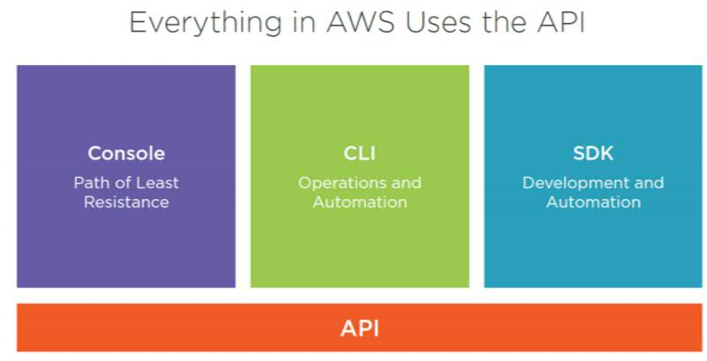

In Aws, everything can be done in 3 ways i.e UI, CLI and Programming language. Whatever the option we use that will be converted as AWS API and performs on AWS.

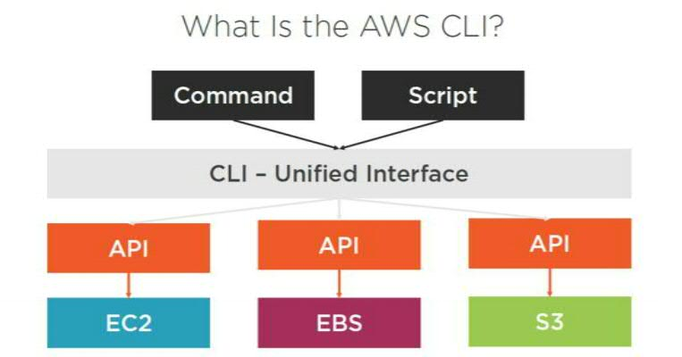

Using CLI, we can use commands or write scripts and run.  
**CLI is available for Windows, MacOS and Linux.**

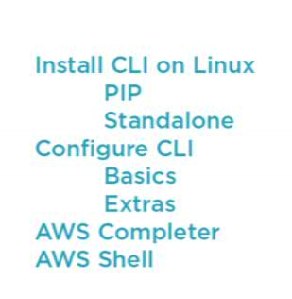

To know the complete commands of Amazon s3 cli, then search in google for **aws s3 cli** and go to amazon’s documentation, there you can see complete list of cli commands. CLI is available for all the flavors of Linux.

To install AWS-CLI on windows, then we have to download msi and double click on it and follow next and next steps.  
  
To install in Linux we have to install **python** as it uses python in background.  
Then we have to install PIP. Then we have to execute a aws-cli command in PIP. Using CLI will be difficult if we are new to it. To simply it we can use **AWS Completer** or **AWS Shell.**  Will see the complete installation later.  
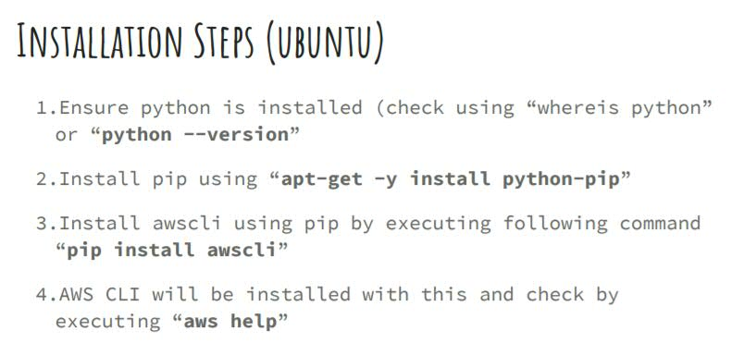

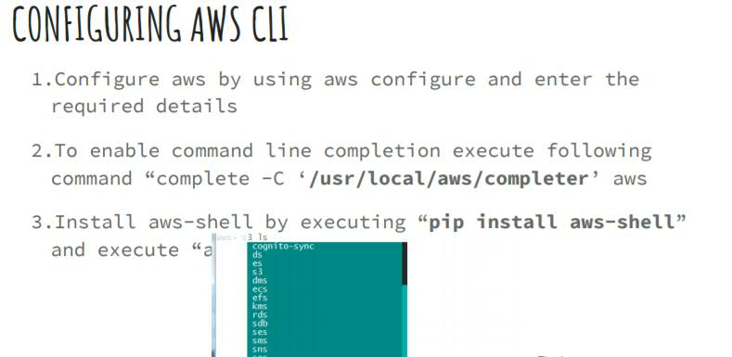

We download aws-cli from a public site and not from our account and install aws-cli. So, when we do any operations using cli, aws will not be aware how is doing the operations. For this we have to configure security with permissions.  
We do this security configuration using IAM. We will discuss this later in detail separately.  
  
But, for now we will create a user with admin permissions and use that user in cli, because cli has to know who is trying to access.  
  
**Installing AWS-CLI in Linux:**

1. **Install python**. Most of the Linux flavors comes with inbuilt python. If not, then we have to install manually.  
   **check for python**: **python**

2) **Then install PIP**. Pip is a package manager for python libraries.  
**apt-get install python-pip -y**

3) **Install aws-cli:** **pip install awscli**

So, the aws-cli will be installed. Just type **aws help**, then it will show the options for aws-cli.  
In the cli console, if we type some option related to aws and click on TAB, then cli should give you some help by showing the possible options. **Ex:** If we type **aws s** and TAB, then it has to show the possible options like **s3, s3api, ses, ses, sqs, sms** . This is called **Completer**. Completer will complete some of the statements we write.  
**Installing Completer**: **complete -C aws_completer aws**

**Installing aws Shell**: **pip install aws-shell**

To verify shell installation using: **aws-shell**

Then it will open aws api console like aws>   
  
There if you type any characters, then it will give the possible options.

For example, type **S**, then it will show the available options for S. If you type **S3** space, then it will give the possible options for S3 like **S3 website.**

AWS is Shell can help you more than Completer and it is rich in API.

In aws shell, if you type **aws ls** (to list all the s3 buckets), then it will say Unable to locate credentials, as we have not configured user credentials. We can achieve this using **aws configure**.

For that we can create user and configure like below.  
Go to aws console, then select **Services** and select **IAM** (Identity and Access Management) (under, Security, Identity & Configure).

Note: IAM is the place where we create users and groups.

Then click on **Users** and click on **Add user.** Then give the **Username** ex:**S3cliuser.**   
Under **Access type**, it will give options to give **Programmatic** and **Console** access to the use. For now, select both.   
Under Console password, it will give **Autogenerated** and **Custom password** options where the Custom password allows us to enter our own password.  
  
If we select the **Require password reset** checkbox, then for every user signin, it will ask user to change the password. But, lets continue without selecting the checkbox and click on Next to move to permissions.

Here we have to set the required access permissions to the user. For now, click on **Attach existing policies directly** then select the **AdministratorAccess** checkbox and click on next.  
Then review the details and click on **Create User.**

Then you can see the User name, Access key ID and Secret access key. These will be showed only once, so download the csv file. You can rename it after downloading if required.   
  
Open the csv file in notepad, there you can see User name, Access key ID and Secret access key and login link to console.

Now go to console and execute the command: **aws configure**

Then enter the access key id. Then enter the secret key. Then enter the region codex: **us-west-2** for US west (origon)).  
Then enter the Default output format as **json** or any other optionor can leave it as none.

Now run the command **aws ec2 help,** it will list all the ec2 options, because awscli knows who you are after configuring.

Now, you can also access the aws console UI (login link), using username and passwords.

To get the help from aws shell to use ec2, then use **ec2 describe- .** Then it will give all the description about ec2.

Then test by typing **ec2 describe-volumes**, this will list all the volumes present.

For anything to find the info about ec2, then type **ec2 describe- ,** then aws shell will give you the help.

You can also get cli help from aws docs as well. For example, to get help about ec2 volumes, then search in google for **aws ec2 describe-volumes** and go to aws documents. <https://docs.aws.amazon.com/cli/latest/reference/ec2/describe-volumes.html>

There you can all syntaxes and examples.

Ex: **To describe volumes that are attached to a specific instance: We use filters for this.**

**aws ec2 describe-volumes --region us-east-1 --filters Name=attachment.instance-id,Values=i-1234567890abcdef0 Name=attachment.delete-on-termination,Values=true**

This example command describes all volumes that are both attached to the instance with the ID i-1234567890abcdef0 and set to delete when the instance terminates.

Let’s do some exercises with ec2 cli.

**Step1:** First, let’s try to create a key pair (pem file), give it some name using cli and use it.

For this search for aws ec2 cli in google and take the reference of aws doc.

Ex link: <https://docs.aws.amazon.com/cli/latest/reference/ec2/index.html>

**aws ec2 create-key-pair --key-name MyKeyPair --region us-west-1 --output text > MyKeyPair.pem**

Then verify the pem file content by using **cat MyKeyPair**

Then (only in Linux), **chmod 400** **<Key_Pair_Name>.pem**

**Step 2:** Then, create a security group: **aws ec2 create-security-group --group-name MySecurityGroup --region us-west-1 --description "My security group**

**Step3:** Adding rules to the created security group (opening ports)

**aws ec2 authorize-security-group-ingress --group-name MySecurityGroup --protocol tcp --port 22 --cidr 0.0.0.0/0**

Here we are saying to allow 22 port number from anywhere.

Repeat the same command with different port numbers to allow multiple.

**Step4:** Launching the instance.

**aws ec2 run-instances --image-id ami-1a2b3c4d --count 1 --instance-type t2.micro --key-name MyKeyPair --security-groups MySecurityGroup**

To know the RedHat AMI id, go to aws shell and type this command:

**aws ec2 describe-images**

Then you will see all the images and their id, select the required one from them. Or get it from console by selecting launch instance.

We can use these security group and key pair for other instances. We no need to create those again. Only AMI needs to be changed further.

**Attaching EBS volume using CLI:**

Search in google for **aws ec2 cli** and select create-volume and follow the doc as reference.

Steps involved are: Create an EBS volume (5GB), then attach it to instance, then format it using ext4, then mount it using mount command and then cross check whether it has been mounted or not using df commands.

Now go to aws-shell to run the commands:

**Creating EBS volume:**

**aws ec2 create-volume --size 5 --region us-east-2 --availability-zone us-east-2a --volume-type gp2**

Here, --size indicates memory size of EBS (5GB). gp2 indicates general purpose volume type.

**Remember:** We have to create the Volume in the same availability zone where the instance exists.

**Attaching a volume to instance:**

To attach a volume to instance, then volume should reside in the same availability zone where the instance exists.   
To attach a volume to an instance, then we need to know the instance id to which we want to assign the volume.

**How to find instance id:**

If you don’t know the instance id, then type **aws ec2 describe-instances** to get the complete list of instances and their related instance ids. From there take the instance id to which you want to attach volume. Instance id looks like **ami-somenumber.** Or else, you can get the instance id by logging to aws console.

**Use below command to attach a volume to instance:**

**aws ec2 attach-volume --volume-id vol-1234567890abcdef0 --instance-id i-01474ef662b89480 --device /dev/sdf**

Then try, **sudo df -h**,

Then try, **sudo fdisk -l**

Here you should see the attached volume. But you cannot use the volume even though it is attached because as it is not formatted.

**Now make a file system (Formatting with file system):**

Use this command to format the file system. Formatting and mounting are purely Linux commands and not AWS commands.

**sudo mkfs -t ext4 /dev/xvdf**

So that your Volume get formatted and now we have to mount it to the instance.

Create a directory **sudo mkdir /my-new-dir**

Then mount it**: sudo mount /dev/xvdf /mnew-dir**

This is a temporary mounting. Once you restart the instance, then your mounting will be removed.

Then try, **sudo df -h**,

Then try, **sudo fdisk -l**

**Detaching Volume:**

To Remove a volume, first we need to remove the mounting for the volume. Then only we can remove the volume.

For this first we have to unmount the volume.

To unmount: **sudo umount /dev/sdf**

Then delete using this command:

**aws ec2 detach-volume --volume-id vol-1234567890abcdef0**

**EC2-Bootstrap**

For example, we want a software to be installed or a script has to run on a instance immediately after launching it. For example, want to install apche2. To achieve this, we can install using yum after launching the instance. But what if we have to install on 10 machines. This can be done in a better way using Bootstrap.

Bootstrap is nothing but, performing some task while launching new instance.  
For example, we want to create a RedHat instance and while launching it, it has to perform some task like installing apache2 (httpd) or running some script. This can be done using ec2-bootstrap.

**First know the manual steps to install apache2**

**yum install httpd -y**

**service httpd start**

To use this with Bootstrap, go to AWS console. Select launch instance, select Amazon AMI, then select General purpose t2.micro instance.

Then in the Configuration Instance Details, you can select multiple instances by giving the number at “Number of Instances”. So that those number of instances will be launched with same configurations.

For now, select only 1 instance and scroll down to Advanced Details. There you can see one option called **User Data**. Bootstrapping in AWS is called as User Data. For User Data, we can see 3 options.   
1) As text, 2) As file, 3) Input is already base64 encoded.  
Select the first option **As Text** and pass the script there. As it is a shell script, we have to give the SheBang line at the starting. For other scripts like Python or Ruby, we have to use different lines. Based on those lines AWS will start running the script.

As we are using Shell script, write the shebang line.

**#!/bin/bash**

**yum -y update**

**yum -y install httpd**

**service httpd start**

Here we can write any shell script as per our requirement. For example, like mounting volume.

The script what we write in Bootstrap will be executed with root user permissions, so we no need to give sudo access or sudo command.

Then click on Next, Next, then give Tag name and Value, then enable default SSH 22 and HTTP 80 (for apache) ports and launch the instance.

After launching the instance successfully, copy the public ip or hostname and try to access apache server from browser.  
[http://ipaddress](http://ipaddress:)

Or check the status from terminal or git bash by connecting to AWS instance. **service httpd status**.

Try this command to know about metadata.

**curl** [**http://ipaddress/latest/meta-data/**](http://ipaddress/latest/meta-data/)

This will list all the details what we can query for. For example: ami-d, hostname, security-groups, instance-id.

Try **curl** [**http://ipaddress/latest/meta-data/instance-id**](http://ipaddress/latest/meta-data/instance-id)

This will give the instance id.

These types of meta-data can be used in the scripts what we use to automate. For example, to attach a volume, we need instance id in the script. So, in those cases we can use these meta-data values.

Try **curl** [**http://ipaddress/latest/user-data**](http://ipaddress/latest/user-data)

This will give the script we written in **User data**.

Now, lets try to add the **User data** using cli. For this you can search in google for **aws ec2 cli for user data**. So that you can use that or reference.

First write down the required shell script in a file. Because we need to pass this file in the cli command.

Now run this command:

**aws ec2 run-instances --image-id ami-abc1234 --count 1 --instance-type m4.large --key-name keypair --user-data file://my_script.txt --subnet-id subnet-abcd1234 --security-group-ids sg-abcd1234**

This command is similar to create instance run-instances command, but with one extra key called –user-data, for this we pass the shell script file location.

**EC2-Classic:** Old version of EC2 (before 2011) where the public and private ip addresses changes for every restart. But in the new version of AWS, only public IP will keep changing for every restart, but the private IP remains same even for terminated systems.

**Creating AMIs:**

We can create our own AMIs for the 1) EBS snapshots and 2) Instances store Volume.

To do with EBS, go to Volumes, then select and stop the volume for which you want to create the AMI.

Then select the Volume and create a snapshot for it, by selecting the Volume and selecting **Create Snapshot** option under **Actions**.

Then go to **Snapshots** (backup of current state of our volume), select the snapshot and then go to **Actions** and select the option **Create Image**.

Then give the details of the image like, name, description, no.of bits (Architecture), Virtualization (paravirtual).

If required, we can add more volumes to it by selecting the option “**Add New Volume**”.

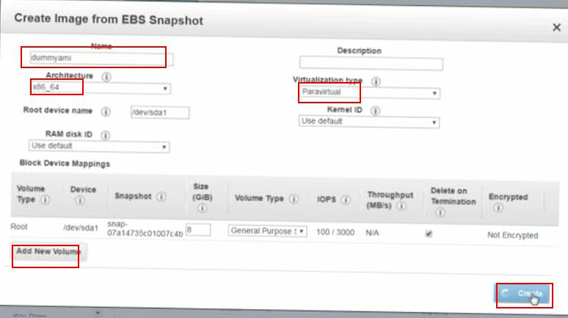  
Then click on “**Create**”.

So that an AMI will be created for you after some time and you can launch that machine directly.

To verify the created AMI, go to AMIs under IMAGES on left side bar.

Or you can go to Launch AMIs and Select My AMIs, there you can see the created AMI and you can launch it.

Why we need Custom AMIs is, for example we need to Linux machine which has Apache and other software’s installed and we need those software’s when we launch an instance. In such cases we create our own AMIs and we re-use those.

**Auto-Scaling**

Increasing/decreasing instances on Demand. Example like on Flipkart big million day.  
If there are many requests coming to my instance and as it doesn’t have capability to handle those many requests, I would like to increase the instances count on Demand for certain point of period and remove those when not required.

There is no equivalent for Auto-Scaling (cloud) in our Physical Setups. So Auto-Scaling is major advantage in Cloud.

For example, I have an instance and is not able to handle the load. In this case I will create 2 more instances to share the load. But all 3 instances will have unique hostnames. But we need to handle the requests with same host. To do this we use load balancer which will load balance the requests between 3 instances.   
But, the load balancer will have some hostname name, but I want to use the hostname as a meaningful name like <https://kctechnologies.com> . To this we use Route 53, which will map the meaningful hostname to actual load balancer. Route 53 will redirect the domain name to load balancer and hostnames.

You can buy a domain in godaddy.com for around 100 rupees.

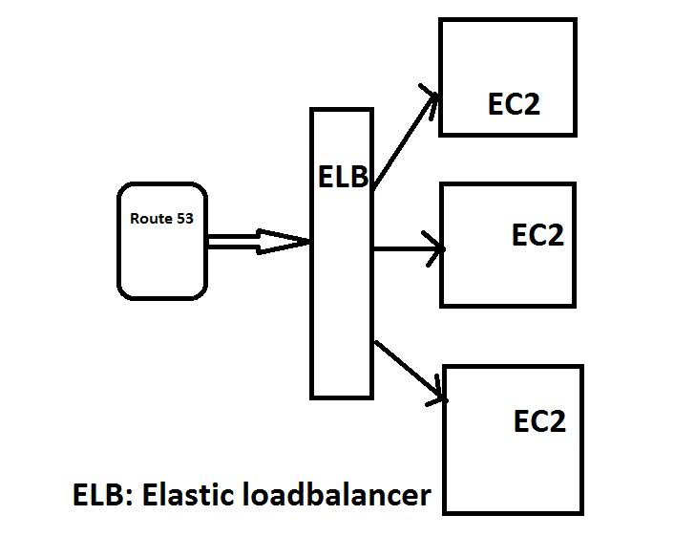

Our actual applications run on EC2.

To do Auto-Scaling, first we need to know the instance to which we have to create load balancing. Then we need to create AMI out of it.

**~~Note:~~** ~~While creating cluster, we should have the instances on different available zones of same region.~~

We cannot have instances on different zones and create load balancing for those.

**Steps to follow for creating Auto -scaling:**

1. Find the instance and create an AMI out of it and create AMI.
2. Create load balancer.
3. Configure autoscaling.
4. Create Route 53.

**Let’s create an AMI with apache and PHP configured on it, so that we can have a static page on it.**

Login to console, go to EC2, select Launch instance, then select Amazons Linux AMI or any other Linux AMI (free tier).

Then select t2.micron, then at **Subnet** select the availability zone as **Default in us-west-2c**, then give a Tag name if required, then enable SSH (22) and HTTP (80) port numbers as it is a web server.

Port numbers are for 2 types: 1) Inbound and 2) Outbound.

Inbound indicates the request comes to our instance, whereas outbound indicates the requests goes from instance to outside world.

We have to configure only inbound rules, by default all outbound rules are enabled in AWS.

Then review and launch the instance. Then connect to the instance from local using pem file and turn as root user.

Then install PHP modules, for this search in google for “installing lamp on RedHat” and then follow the steps.

Install apache: **sudo yum install httpd -y**

Start apache: **service httpd start**

To start apache on every boot (start of Linux): **chkconfig httpd on**

Verify http is working or not, by accessing it from browser <http://publicipaddress>

Then install php**: sudo yum install php php-mysql -y**

They verify, our application is able to host php information or not.

Go to the home page using **cd /var/www/html/**

There create a file called index.php and copy below text to it.

**<?php phpinfo(); ?>**

Then restart http service using **service httpd restart**

Verify http is working or not, by accessing it from browser <http://publicipaddress>

So that you will see many details about PHP, then scroll down and there you can see **SERVER_ADDR** which is the ipaddress.

Now, let’s create an AMI out of EC2 machine. We have seen creating AMI out of Volume earlier.

For this go to AWS console and select the EC2 instance and right click on the instance, then go to image and the select **Create Image.**

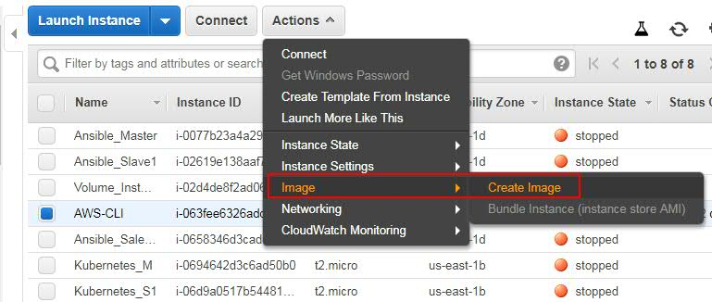

Then give the Image name and Image description. Also select the reboot check box. It is not mandatory but recommended.  
If we require, we can add extra volumes too, by click on Add Volumes, but we will not add for now. Then click on **Create Image**.

Then once the reboot completes, then an image will be created.

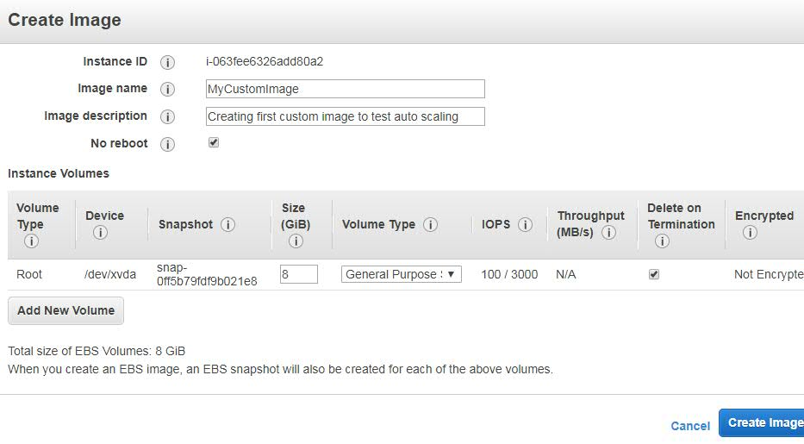

**Note:** To make an AMI public, right click on the AMI then select Modify Image permissions and select the public radio button. Or else we can share the AMI only to specific user by giving the AWS account number. If we make the AMI public, then everyone will be able to access it.

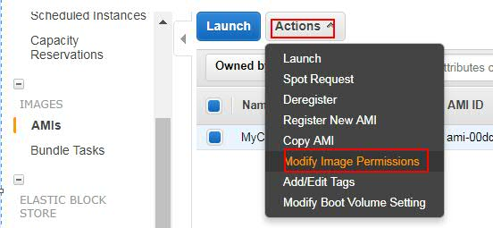

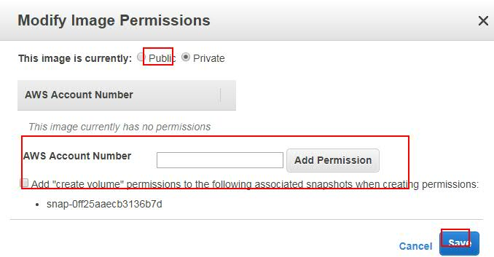

Now go to AMIs under IMAGES and check our AMI is created or not.

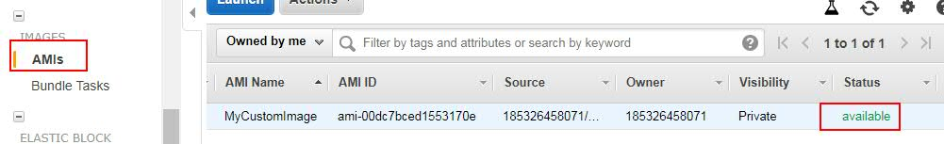

Now go to the instances and then delete the original instance.

Then, go to EC2 launch instance, select my AMIs, and then select the AMI what we created and launch it.

**Now, let’s create Load balancer:**

We can create Load balancer only when our AMI is ready.

From AWS EC2 console, select Load balancers from left menu.

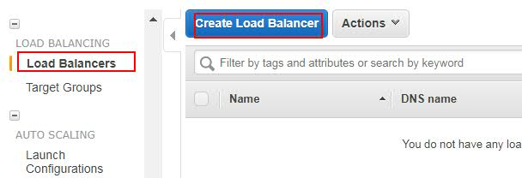

Before creating Load balancer for Auto scaling, let’s create a general load balancer with 2 instances.  
**Note:** This is just a demo to create general load balancer but not the actual approach we follow for autoscaling.

Load balancer is created between EC2 instances.

For this, first create 2 EC2 instances with the AMI we created.

**Creating First instance from custom AMI:**

For this, Go to AMIs under IMAGES, then select the image we created, right click on it and select Launch.

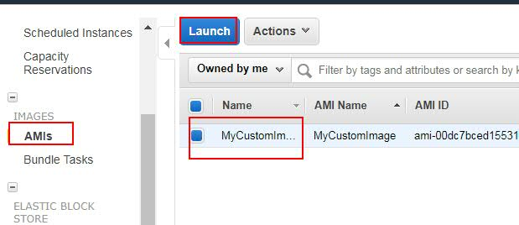

Then click on next, select t2.micron and click on next.  
Then select the **Subnet** as **public-1 | Default in us-west-2c** availability zone.

Then click on **Add Storage**, then **Add Tags**, then give the Tag name if you want and click on **Configure Security Groups**.

Then create a security group by enable HTTP 80 and SSH 22 ports.

Or else select a Security group if already exists.

Then click on **Review and Launch** and then **Launch**.

Then select the existing key pair (pem file) or create a new key pair and click on **Launch Instances**.

**So that our First instance will be created.**

**Creating Second instance from custom AMI:**

For this, Go to AMIs under IMAGES, then select the image we created, right click on it and select Launch.

Then click on next, select t2.micron and click on next.  
Then select the Subnet as **public-2 | Default in us-west-2b** availability zone.

Then click on **Add Storage**, then **Add Tags**, then give the Tag name if you want and click on **Configure Security Groups**.

Then create a security group by enable HTTP 80 and SSH 22 ports.

Or else select a Security group if already exists.

Then click on **Review and Launch** and then **Launch**.

Then select the existing key pair (pem file) or create a new key pair and click on **Launch Instances**.

**So that our Second instance will be created.**

Now we have 2 instances ready in 2 different availability zones which has same application (webserver).

**Now let’s create load balancer for the created 2 instances:**

Go to **Load Balancers** under **LOAD BALANCING** on left menu.



Then click on **Create Load Balancer**.

Then you can see 2 types of Load balancers.  
1) **Application Load balancer** and 2) **Classic Load Balancer**.

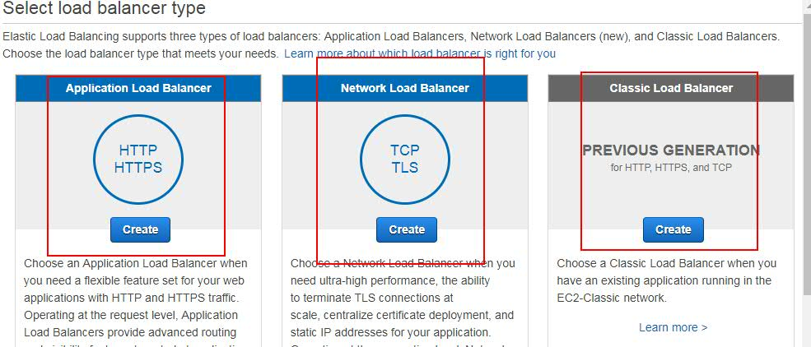

Application Load Balancer is load balancing on the Top most application layer i.e Layer 1.  
Where as the Classic Load Balancer is load balancing on Layer 4.

Normally we have Layer 1, Layer 4 and Layer 7 of TCP model.

In short to remember, Application Load Balancing can be applied only when our ports are 80 and 443(HTTP/HTTPS). This is a new feature.

Classic Load Balancing can be applied to any application with any port.

For now, let’s go with Application Load Balancing which is new approach.

Select Application Load Balancer and click on **Continue**.  
  
Then you will see few options, let’s see what those are.  
**Load Balancer Name:** Give some name for it.

**Create an internal load balancer**: If we select this option, then this load balancer will be available with in VPC and can’t be available to outside world. But we need to allow to access this load balancer from outside world, so we are not going to select this option.

We see few more options called **Load Balancer Port** and **Instance Port**. This indicates, if a request come to load balancer with the port number mentioned on Load Balancer Port, then where it has to redirect to (Instance Port). Just like using redirect ports for Jenkins.

**Enable advanced VPC configuration:**  If we select this option, then we will get one more option called Select Subnets.

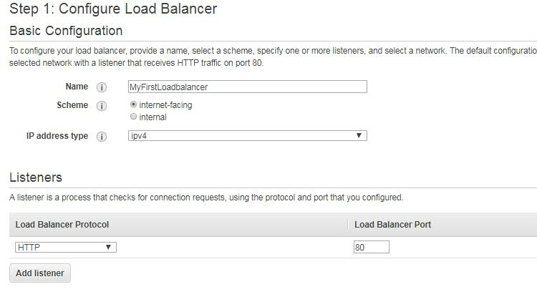

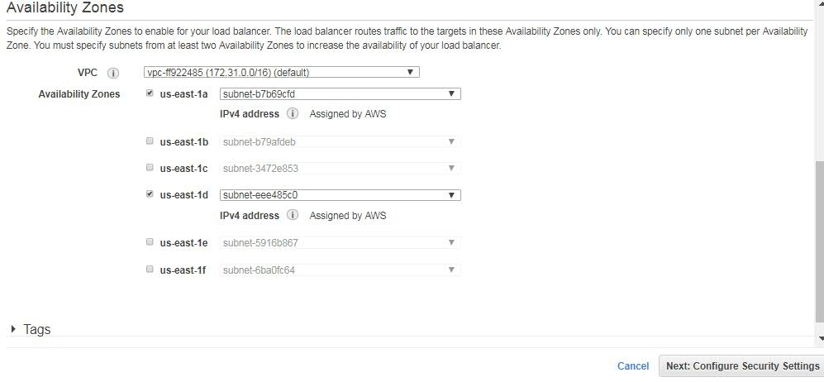

Then scroll down to the Subnets and select the availability zones we require. As we created the images on us-west-2b and us-west-2c, select those 2 and click on **Assign Security group**.

Then select the Security group. As we require only 80 and 22 ports for this load balancer, select those from existing Security group or create a new Security group with 80 and 22 ports.

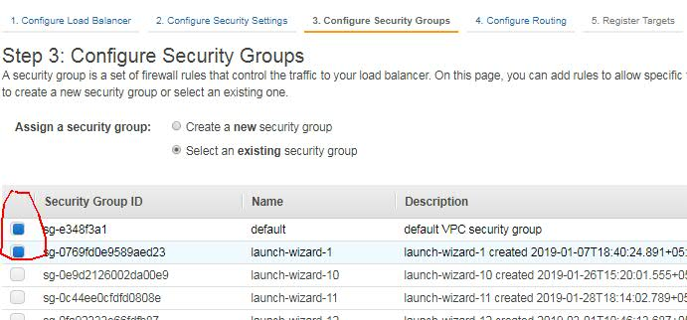

Then it will ask to improve your security. This is because as we are using HTTP, it is asking to improve security using HTTPS.

For now, leave it as it is and click on **Configure Health Check**.

Then **Configure Health Check:**

Load balancer is not only to redirect the traffic, it also needs to know which nodes are healthy and which are unhealthy, because it has to know the node health before redirecting the traffic.   
So we have to configure few details to check the Nodes health.

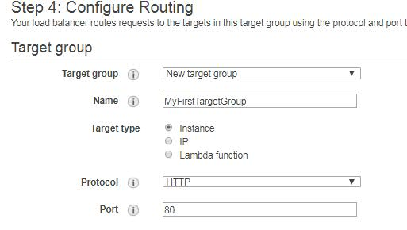

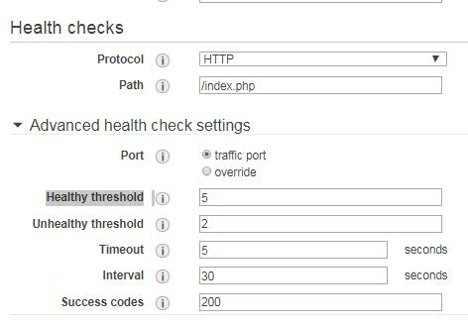

Here, **Ping Protocol** indicates what the protocol do the load balancer should use to connect to the Nodes to check health.

**Ping Port** indicates what port it has to use.

**Ping Path** indicates what file it has to check for health. He as we have index.php as the home page, we are configuring it.

**Response Timeout** indicates, how many seconds load balancer has to wait for the response.

**Interval** indicates for how many seconds of interval it has to check the Node health.

Always Response timeout should be lesser than Interval.

**Unhealthy threshold** indicates, how many times the load balancer has to check to indicate the Node as unhealthy.

**Health threshold** indicates, how many times the load balancer has to check to indicate the Node as back to healthy.

Then click on **Register Targets**.

Then select the 2 instances what we created and to which we want to create load balancing and Click on **Add Tags**.

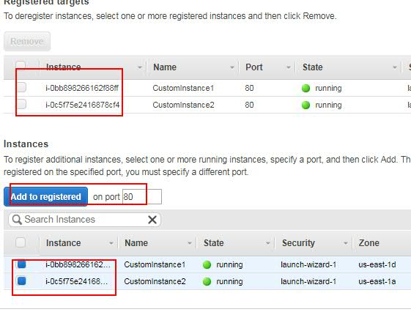

Give the Key and values with some names to identify and click on **Preview and Create**. Then review the details and click on **Create**.

So that a load balancer is created successfully.

So the load balancer domain name will be something which we cannot read. Ex: **my-web-clib-123456-us-west-2-eclb-amazonaws.com**

Now go to the Instances section of the Load balancer.

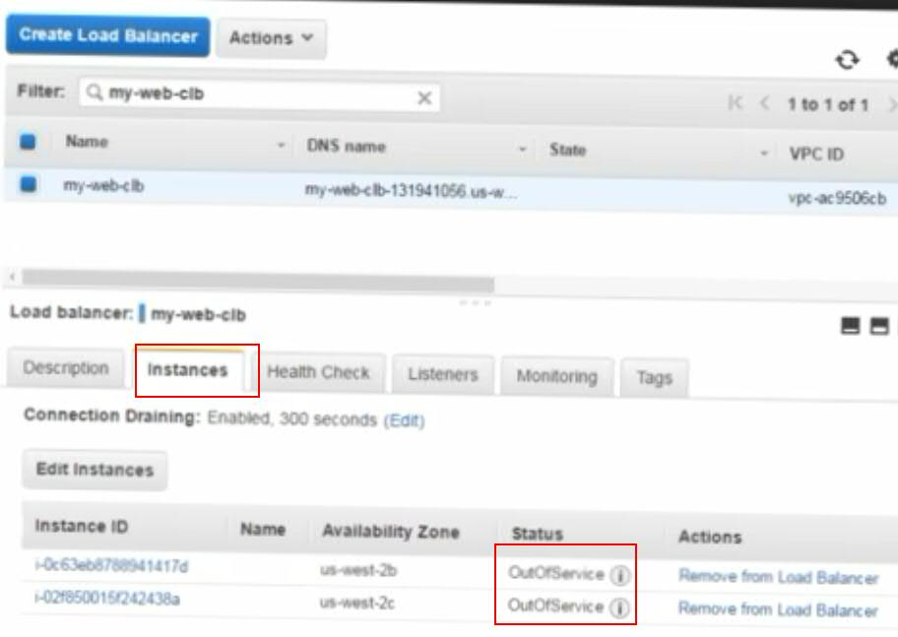

There you can see the instances status as **OutOfService**, because the health checks have not yet been done and it takes sometime to do health checks. Instances will be available only when the health check is done.

Now go and click on the **Health Check** option which is right side to **Instances**.

Once the health check is done, then the Status of the instances will be **InService**. It takes some time to do the health check, once the health check is done and the Status is InService, then hit the load balancer url.

**Ex: my-web-clib-123456-us-west-2-eclb-amazonaws.com**

Or try with direct instance host/index.php

When you hit the load balancer url, php index page will be opened. Then scroll down and check the ip address. For every refresh you see different ip addresses of the 2 instances as the load balancer will serve the requests between 2 instances.

So far whatever we done is load balancing between 2 static instances, but we want to achieve the same for Auto-scaling instances.

To achieve this, first let’s delete the existing load balancer. Select the load balancer, then go to **Actions** and click on **Delete**.

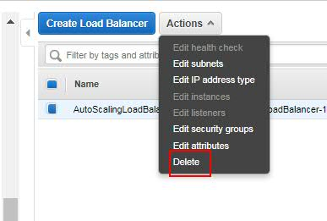

Then go to **Services** and open **EC2** on 2 tabs, as we have to work on 2 things parallelly.

Then from the 1st TAB, create a load balancer:

Go to **LOAD BALANCING**, select **Load Balancers**, select **Application Load Balance**r and click on **Continue**.

Then give the **Load Balancer Name**, but don’t select any instances. Also select **Enable Enhanced VPC configuration**.

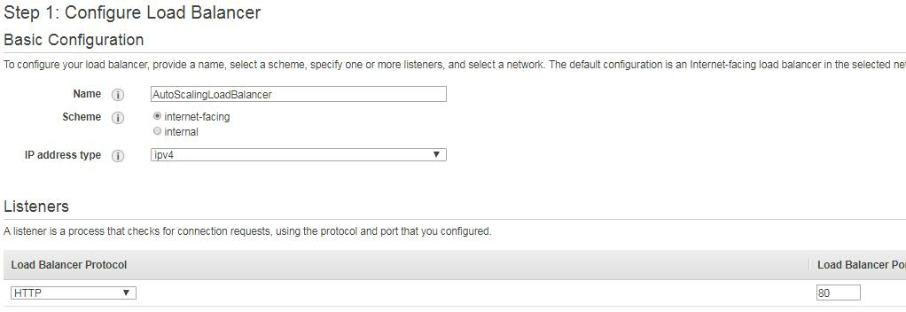

Then go to **Select Subnets** and the required availability zones required. Ex: **us-east-1a** and **us-west-1d** and click on **Configure Security Settings**.

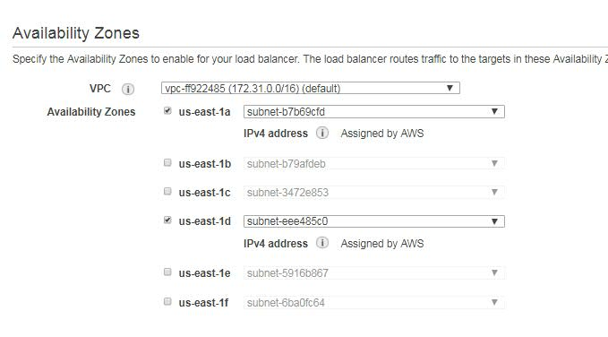

Then select required Security Group if already exists or else create and select and click on **Configure Security Settings**.

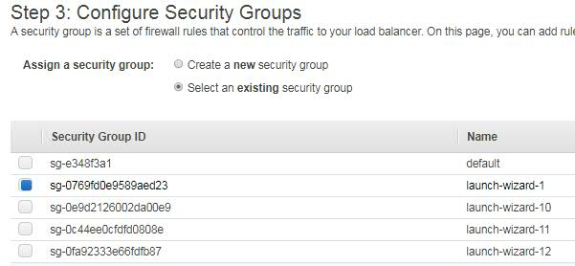

Then click on **Configure Routing**, then give the required **Target group** and **Health Check** details to check and click on **Add EC2 Instances**.

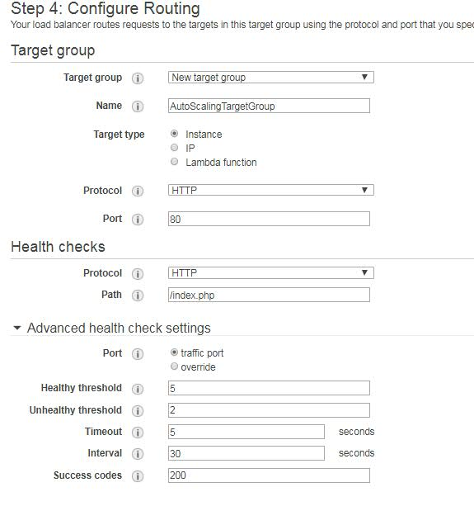

After that click on **Register Targets**. But don’t select any instances as we have to create Auto scaling and click on **Add Tags**, then give some key and value names and click on **Review and Create**, then click on **Create**. So that a Load Balancer is created.

Now Terminate the existing instances, to which we have crated load balancing earlier.

**Now, let’s create an Auto Scaling Groups:**

Go to Auto **AUTO SCALING** from left navigation options.

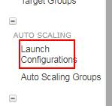 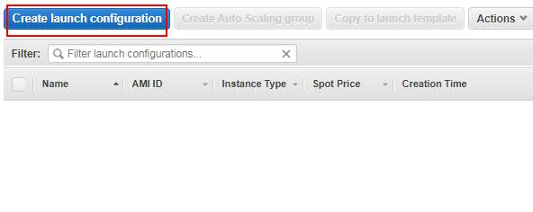

There you can see **Launch Configuration** and **Auto Scaling Groups** options. Select **Launch Configurations** option and then select **Create launch Configuration**.

**Note:** **Launch Configurations** says about AMI and its Security Group.

Then select the AMI which we want to launch. In our case, we have to select the AMI we created for Auto Scaling. For this go to MY AMIs and select the AMI.

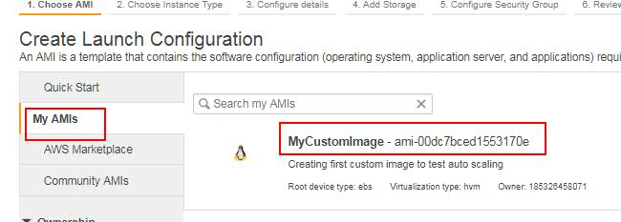

Then select the type of the machine. As we are using free account, select **t2.micro** and click on next. Then give some name for it, then select Purchasing option only if we required Spot instances (Spot instances are those we purchase by bidding). We can also select an AMI role if required. But we are not selecting and role for now.   
  
Under, Advanced Details, we can pass bootstrap data if required, then select the Assign Public IP address radio option and click on **Add Storage** option.  
Then select any existing Security Group or create and select one if doesn’t exists.

Then **Review** and **Create** **Launch Configuration**. Then select the Security key. 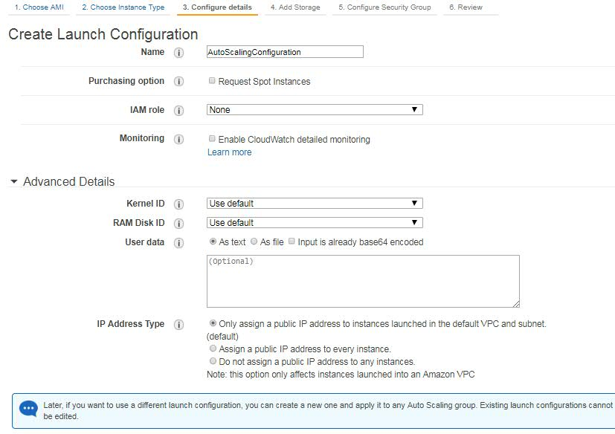

Then you will see an option “**Create an Auto Scaling group using this launch configuration**”. Click on this option to create auto scaling.

**Create an Auto Scaling group using this launch configuration:**

This option is used to create Auto scaling with the configured AMI.

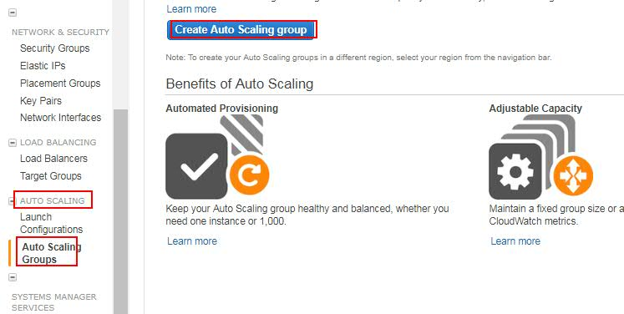

Then select **Launch Configuration** and click on Next.

Select **Create a new launch Configuration** option if you want to create new, else select **use an existing launch configuration** if you already have it.

For now, select **Use and existing launch Configuration** as we already created a configuration, select the created configuration and then click on Next.

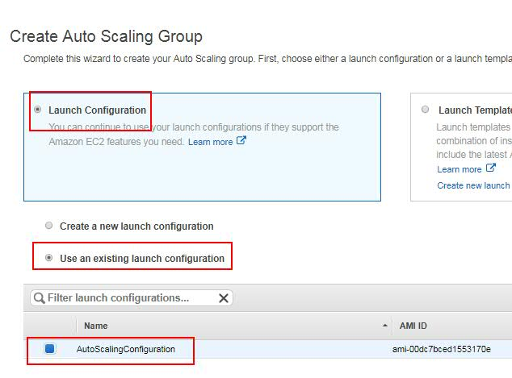

After selecting this option, few details have to be given.  
**Group name:** Give some name

**Group Size:** Give some number which indicates the default required no.of instances.

**Network:** Select the default or existing VPC or create one if required.

**Subnet:** Select the required Subnets.

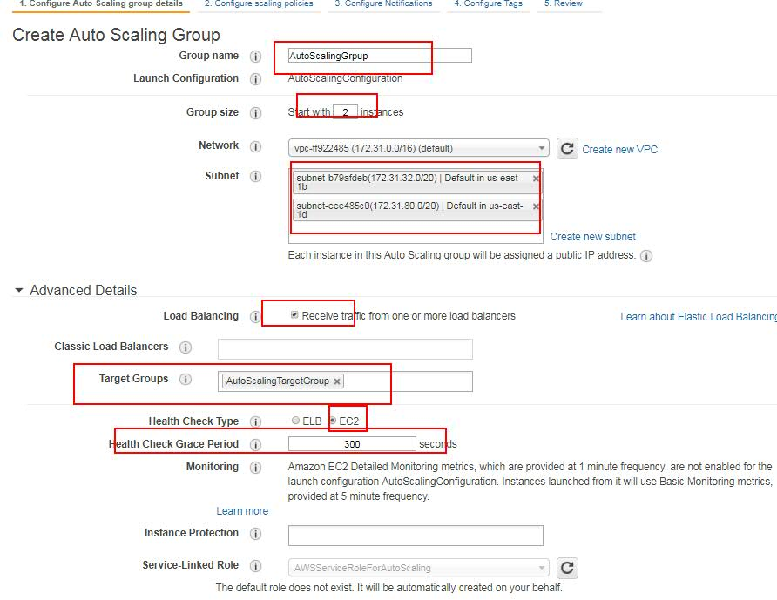

Then, under Advanced Details we have to configure some more details.

**Load Balancing:** This indicates the configuration of Load balancer.

Once we select this, then we will see 2 more options.

1. **Classic Load Balancer:** This will list the load balancers what we created using **Classic Load Balancer** option.
2. **Target Groups**: This will list the Load Balancers what we created using **Application Load Balancer** option.

Here, we have to select the Classic Load Balancer we created using Classic Load Balancer option.

**Health Check Type:** This indicated the type of health check we require. Here we need Elastic Load balancer health checks, so select **ELB**.

**Health Check Grace Period:** Select the seconds it has to check.

**Instance Protection**: If we select this option, then the selected instances will not get terminated during Auto scaling.

Give the details and click on **Configure Scaling Policies**.

Under Configure Scaling Policies, we can see to Options.

1. **Keep this group at its initial size**: Which indicates the instances size to a static number what we defined while creating. The difference between this option and the normal load balancing is, this option will maintain the same no.of instances always. For example, if an instance is terminated because of some issue, this it will create one more automatically based on launch configuration. Whereas the normal load balancer will not do this.
2. **Using scaling policies to adjust the capacity of this group:** This will create auto scaling. Based on the load it will increase and decreases the instances count.

As we need to do Auto Scaling, we will select **Using scaling policies to adjust the capacity of this group** option.

Then we need to give some configuration details:

**Scale between:** Here we have to specify, minimum and maximum no.of instances required while auto scaling.

**Name**: Its name to identify.

**Execute policy when**: This indicates, when to increase the group size. To do this we need to create and Alarm to check the condition.

Click on the **Add Alarm** option.

After that, you need to create a Topic, so click on **create topic** option.

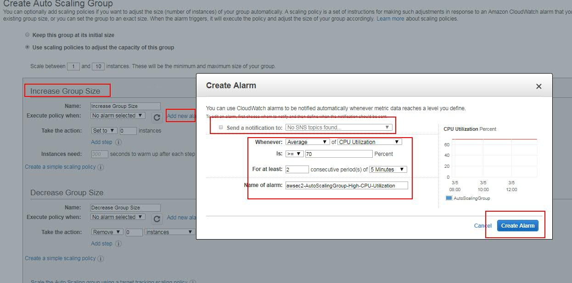

Enter, Topic Name, then enter emails to whom it has to send email alert.

**Whenever**: This indicates the condition when the instances has to be increased. For example, when the CPU utilization is more than 70%.

Give the details and click on Create Alarm.

Then **Take the action**: It indicates the no.of new instances to be launched when the Alarm condition is satisfied. This is to increase no.of instances.

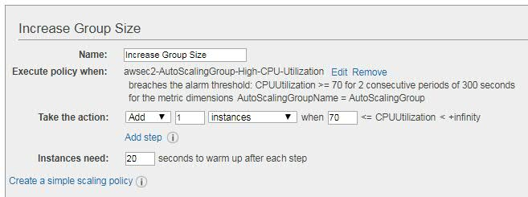

Then same way we have to decrease the no.of instances when a condition is satisfied.

For this too, we need to create an Alarm. So, click on **Add new Alarm**.

Then give the conditions required.

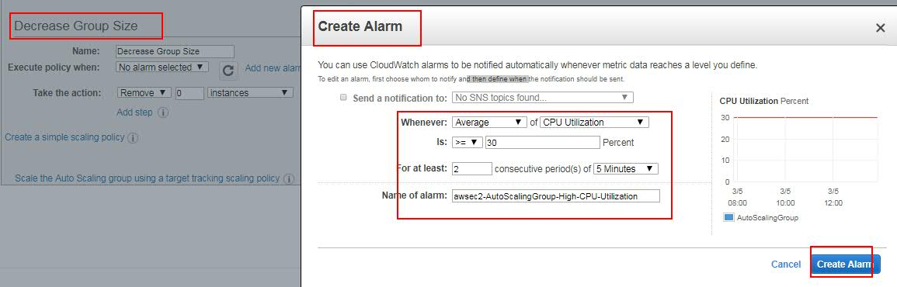

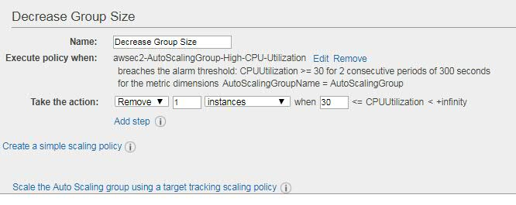

Enter the details and click on **Configure Notifications**. As of now, we no need to configure any notifications, so click on **Configure Tags**.

Then give the Tag name and value if required, then Review and click on “**Create Auto Scaling group**”.

Then click on, View your Auto Scaling groups to see the details. Then go to instances. There you can see only 2 instances.

Take the load balancer ip address or host name and hit from browser.

**Security Groups:**

